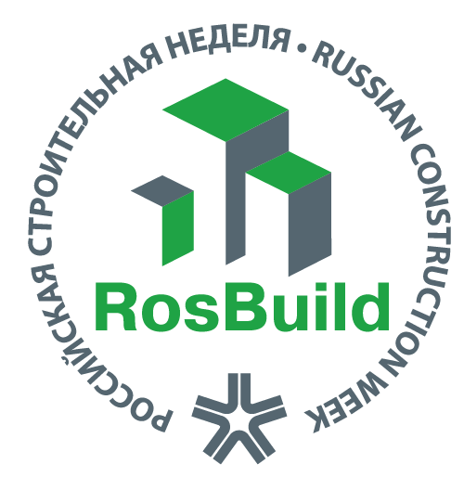 | RUSSIAN CONSTRUCTION WEEK-2020  EXPOCENTRE, AO, 123100, Russian Federation, Moscow, Krasnopresnenskaya nab., 14  Phone: +7 (499) 795-37-36, 795-38-82  E-mail: ts@expocentr.ru; zaedinova@expocentr.ru
PRELIMINARY APPLICATION FOR PARTICIPATION
RosBuild - 2020
International Exhibition of Building, Finishing Materials and Technologies
Expocentre Fairgrounds, Moscow. Russia
31 March – 03 April, 2020

INFORMATION:
The Company applicant
Country: |  |  |  |  |  | City:
Postal address:
The Contact Person:
Position
Phone No.: |  |  |  |  |  |  | Fax No.:
E-mail: |  |  |  |  |  |  | Web-site:

EXHIBITION SPACE RENT:
Indoor, raw | sq.м
Indoor, standard-equipped | sq.м
Open-air | sq.м
Please state weather your company is a producer: yes / no (please underline the correct answer)

PLEASE MARK THE NECESSARY CATEGORY OF EXHIBITION THEME SUBJECT BELOW WHICH CORRESPONDS TO YOUR PRODUCTION PROFILE DURING THE EXHIBITION

THEMATIC SECTORS |  | THEMATIC SECTORS
Building materials |  | Floor coverings
Bathrooms |  | Doors, locks
Ceramic tiles. Stone |  | Interior fabrics
Wallpaper, panel, moldings |  | Smart Living
Paints and decorative coatings |  | Facades. Roofing
Lighting and Electrical products |  | Construction machinery
Equipment. Tools |  | Energy Saving Technologies
Engineering systems |  | Recycling and Environmental Technologies
Land improvement. Landscape architecture |  | Architecture. Design
Metal products |  | Metal structures
Prefabricated buildings |  | Wooden house building
Insulation materials |  | IT solutions, business services
Windows, translucent structures |  | Other (please specify)_____________________
Please indicate the represented trademarks, describe your products and mention the country of origin

TRADEMARK | PRODUCTION | THE COUNTRY

The authorized representative of the applicant / / « » 201__
(Name) (Signature) Company seal (Date)

